

Countdown to Your Say 2024

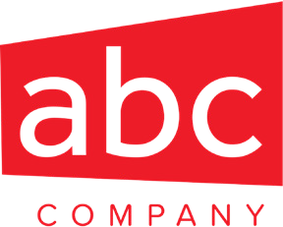


{ABC Company} is dynamic, thriving company because of our people.

Tell us
what's on
your mind

That’s why we want to hear what you have to say in our upcoming ‘Your Say’ employee survey.

Please look out for it in early {Month} and be prepared to participate.

